# Anonymity

# Relevance

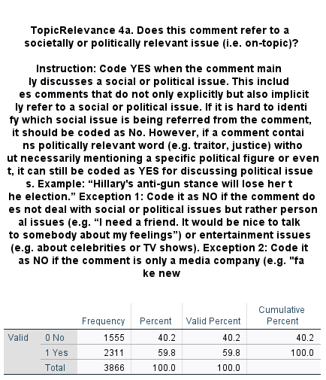

# INTERACTIVITY

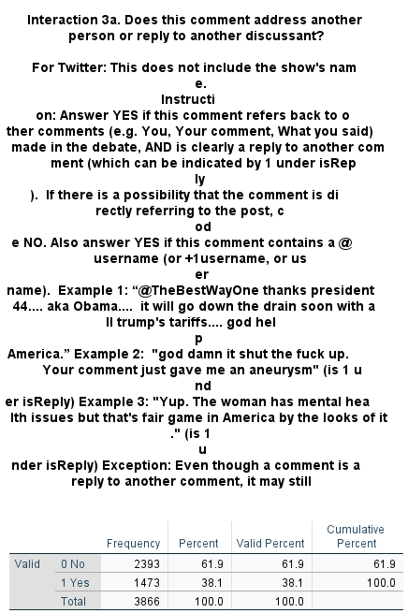

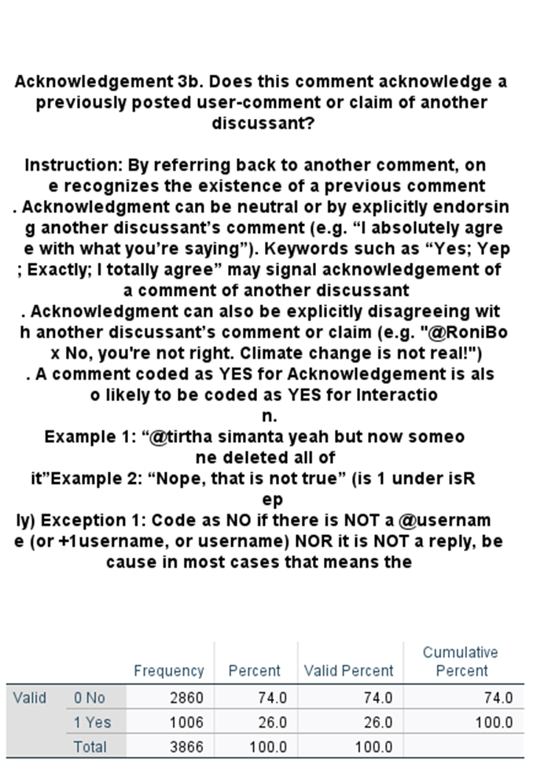

# RATIONALITY

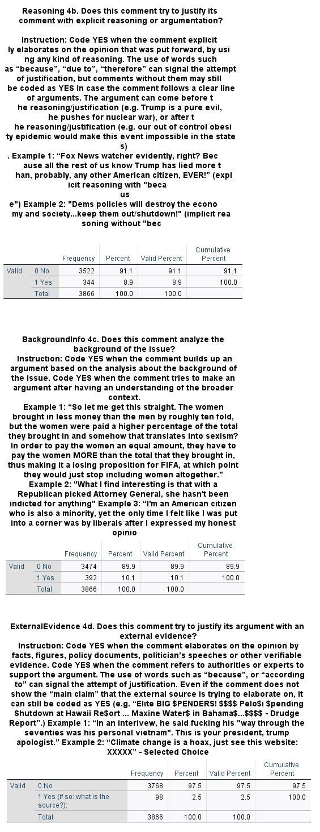

# DIVERSITY

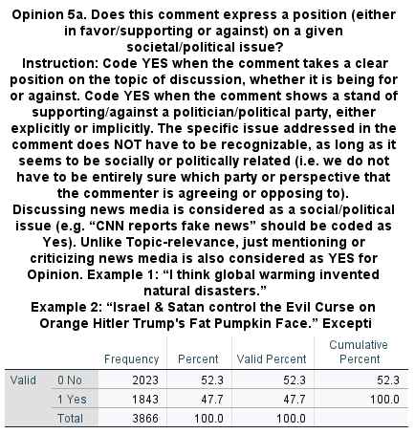

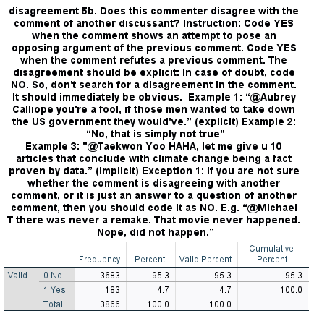

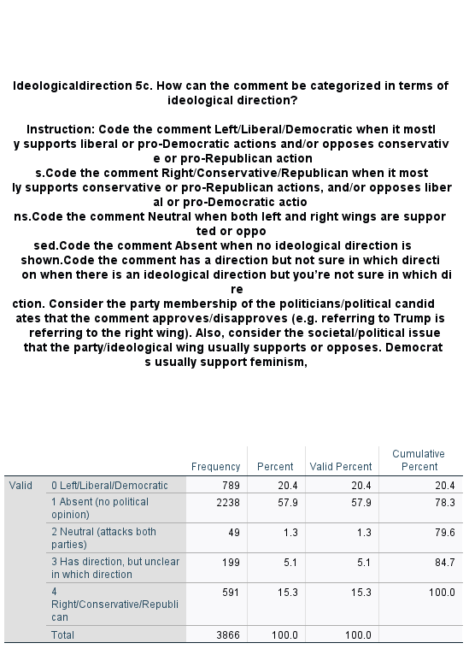

# INCIVILITY

See details below.

# How Variables are Calculated

* INTERACTIVITY_DUMMY = Acknowledgement

* RATIONALITY_SUM = Reasoning + BackgroundInfo + ExternalEvidence
* RATIONALITY_DUMMY = if RATIONALITY higher than 0

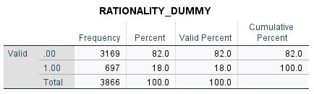

*Diversity and incivility on next pages.*

Diversity

* HAS_OPINION_DUMMY = If SUM(Opinion, Disagree_political, Ideology_present) higher than 0

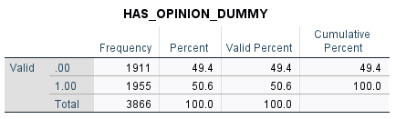

* LIBERAL_NEUTRAL_CONSERVATIVE = ordinal scale

* LIBERAL_DUMMY

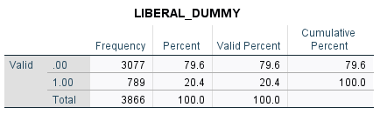

* CONSERVATIVE_DUMMY

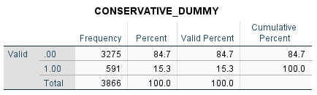

Incivility

* NAMECALLING_DUMMY

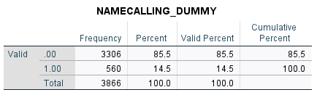

* VULGAR_DUMMY

* NAMECALLING_VULGAR_DUMMY

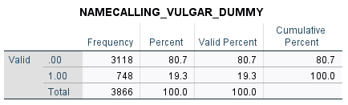

*These three may most overlap with simple dictonaries*

* INCIVILITY_ORDINAL = if SUM( NAMECALLING_DUMMY, VULGAR_DUMMY, REPUTATION_DUMMY, INTELLIGENCE_DUMMY, ALLCAPS_DUMMY, SARCASM_DUMMY, RIGHTS_DUMMY, DISCRIMINATE_DUMMY, VIOLENCE_DUMMY) larger than 1 or 2.

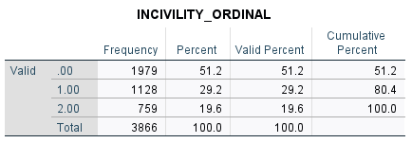

* INCIVILITY_DUMMY

* INTOLERANCE_DUMMY = IF =SUM(RIGHTS_DUMMY, DISCRIMINATE_DUMMY, VIOLENCE_DUMMY) is greater than 0.

**For the automated analysis:**

Try to create different combinations of the best performing dictionaries — as they may cover different dimensions of incivility. So, having some combined may lead to a better outcome.

In our previous article, we called it “Combined approach”, but I’m sure there must be a better term for it. <https://www.tandfonline.com/doi/full/10.1080/19312458.2019.1671966>